ROSSMOYNE SENIOR HIGH SCHOOL


Yr11 Semester Two Examination, 2012

Question/Answer Booklet

MATHEMATICS SPECIALIST 3A/3B MAS

Section Two:

Calculator-assumed

Your name

Teacher’s name ______________________________________

Time allowed for this section
Reading time before commencing work: ten minutes
Working time for this section: one hundred minutes

Materials required/recommended for this section

To be provided by the supervisor
This Question/Answer Booklet
Formula Sheet (retained from Section One)

To be provided by the candidate
Standard items: pens, pencils, pencil sharpener, eraser, correction fluid/tape, ruler, highlighters

Special items: drawing instruments, templates, notes on two unfolded sheets of A4 paper, and up to three calculators satisfying the conditions set by the Curriculum Council for this examination.

Important note to candidates

No other items may be used in this section of the examination. It is your responsibility to ensure that you do not have any unauthorised notes or other items of a non-personal nature in the examination room. If you have any unauthorised material with you, hand it to the supervisor before reading any further.

Structure of this paper

Section | Number of questions available | Number of questions to be answered | Working time (minutes) | Marks available | Percentage of exam
Section One:  Calculator-free | 7 | 7 | 50 | 50 | 33
Section Two:  Calculator-assumed | 13 | 13 | 100 | 100 | 67
 |  |  | Total | 150 | 100

Instructions to candidates

- The rules for the conduct of Western Australian external examinations are detailed in the Year 12 Information Handbook 2012. Sitting this examination implies that you agree to abide by these rules.

- Write your answers in the spaces provided in this Question/Answer Booklet. Spare pages are included at the end of this booklet. They can be used for planning your responses and/or as additional space if required to continue an answer.
- Planning: If you use the spare pages for planning, indicate this clearly at the top of the page.
- Continuing an answer: If you need to use the space to continue an answer, indicate in the original answer space where the answer is continued, i.e. give the page number. Fill in the number of the question(s) that you are continuing to answer at the top of the page.

- Show all your working clearly. Your working should be in sufficient detail to allow your answers to be checked readily and for marks to be awarded for reasoning. Incorrect answers given without supporting reasoning cannot be allocated any marks. For any question or part question worth more than two marks, valid working or justification is required to receive full marks. If you repeat an answer to any question, ensure that you cancel the answer you do not wish to have marked.

- It is recommended that you do not use pencil, except in diagrams.

Section Two: Calculator-assumed (100 Marks)
This section has thirteen (13) questions. Answer all questions. Write your answers in the spaces provided.

Working time for this section is 100 minutes.

Question 8 (4 marks)
A function is defined as 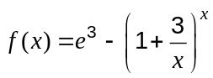.

(a) Find 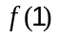. (1 mark)

(b) Calculate 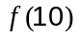,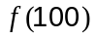 and 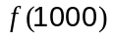. (2 marks)

(c) State the exact value of 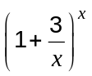 as . (1 mark)

Question 9 (10 marks)
When a capacitor discharges through a resistor, the voltage, in volts, across the capacitor decays according to the rule 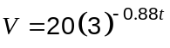, where is the time, in seconds, after the discharge began.

(a) What was the initial voltage across the capacitor? (1 mark)

(b) What was the voltage across the capacitor after four seconds? (1 mark)

(c) Draw the graph of the voltage against time for 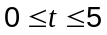. (3 marks)

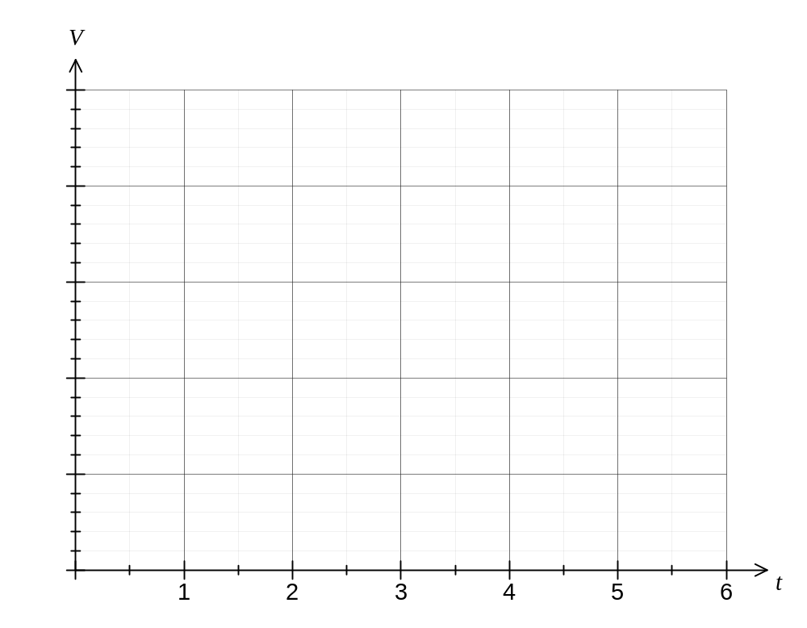

(d) How long, to the nearest millisecond, does it take for the voltage across the capacitor to halve? (3 marks)

(e) How long does it take for the capacitor to become 99.9% discharged from its initial state?
(2 marks)
Question 10 (10 marks)
Three points are given by 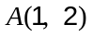, 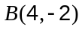 and 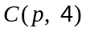.

(a) Determine a unit vector parallel to the line through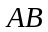. (2 marks)

(b) Write down a vector equation of the line through. (1 mark)

(c) Find the value of if the lines through and 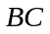 are perpendicular. (3 marks)

(d) Find the coordinates of 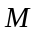, the mid point of 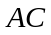. (1 mark)

(e) Determine the vector equation of the circle through points , and . (3 marks)

Question 11 (7 marks)
(a) A vertical pole stands on level ground. From point A on the ground, the angle of elevation of the top of the pole is 44°. Point B is 2 m nearer to the base of the pole than point A, and from point B, the angle of elevation of the top of the pole is 55°. Find the height of the pole, rounding your answer to the nearest centimetre. (3 marks)

(b) A triangle has sides of length 10 cm and 11 cm and an angle of 110°.

(i) Sketch all possible triangles with these attributes. (1 mark)

(ii) Find the smallest possible area of a triangle with these attributes. (3 marks)

Question 12 (7 marks)
(a) Convert A(0, 5) from Cartesian to polar form. (1 mark)

(b) Convert B(2, 2) from polar to Cartesian form, correct to 2 decimal places. (2 marks)

(c) Convert the Cartesian equation 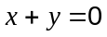 , for 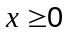, into polar form. (1 mark)

(d) Convert the polar equation 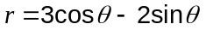 into Cartesian form. (3 marks)

Question 13 (9 marks)
The points 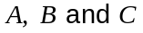 have position vectors 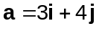, 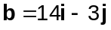 and 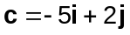.

(a) Determine the angle between vectors and , giving your answer rounded to one decimal place. (2 marks)

(b) Find the position vector of point 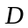 which divides 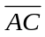 internally in the ratio 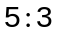.
(3 marks)

(c) Express the vector in terms of and . (4 marks)

Question 14 (9 marks)
Two circles, one of radius 8 cm and the other of radius 18 cm, with a common tangent, touch each other as shown in the diagram. | 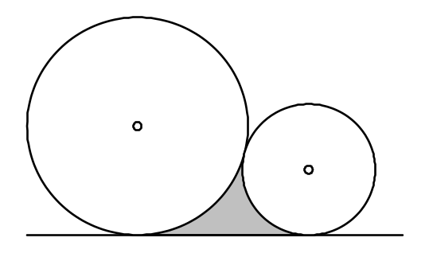

(a) Calculate the perimeter of the shaded region. (5 marks)

(b) Calculate the area of the shaded region. (4 marks)

Question 15 (7 marks)
A fishing boat leaves a harbour with position 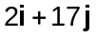 and motors with a constant velocity of 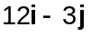 km/h. On the shore, a radio station has position 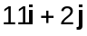 km, and the signal from the station can be detected up to 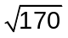km away.

(a) Write down a position vector for the fishing boat hours after leaving the harbour.
(1 mark)

(b) Write down the vector equation for the circle representing the boundary of the radio signal from the shore station. (1 mark)

(c) Show that the fishing boat will be within range of the radio signal for a period of 40 minutes during its journey. (5 marks)

Question 16 (8 marks)
Prove that

(a) 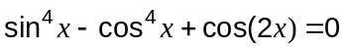. (4 marks)

(b) 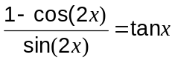. (4 marks)

Question 17 (8 marks)
The graph of 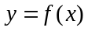 is shown, where 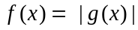 and 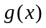 is a linear function.
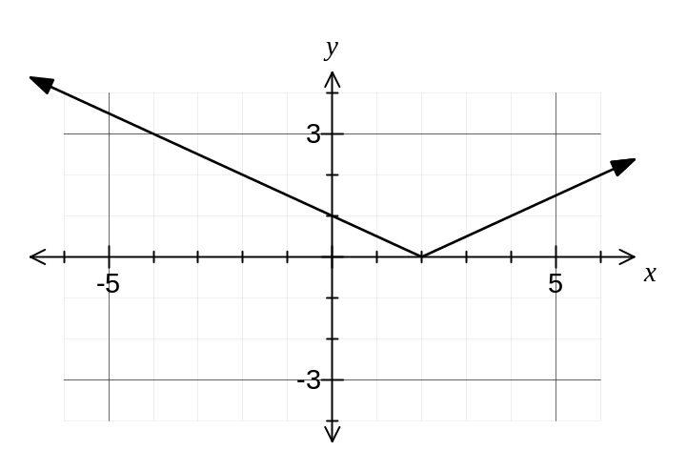

(a) Find a function for . (2 marks)

(b) Is  continuous and differentiable over its natural domain? Explain your answer.
(2 marks)

(c) Add the graph of 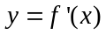 to the axes above. (2 marks)

(d) Write 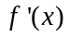 as a piecewise defined function. (2 marks)

Question 18 (7 marks)
A helicopter, with a maximum speed through still air of 240 km/h, leaves its base at A to fly to a destination at B.

The position vector of B relative to A is 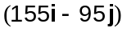 km, and a steady wind of velocity 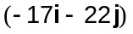 km/h is blowing over the area.

(a) Find the velocity vector the helicopter pilot should set in order to fly directly from A to B in the shortest time. (5 marks)

(b) What is the shortest journey time, to the nearest minute? (2 marks)
Question 19 (9 marks)
A function is given by 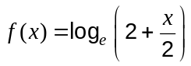.

(a) Sketch the graph of on the axes below, clearly showing any asymptotes.
(3 marks)
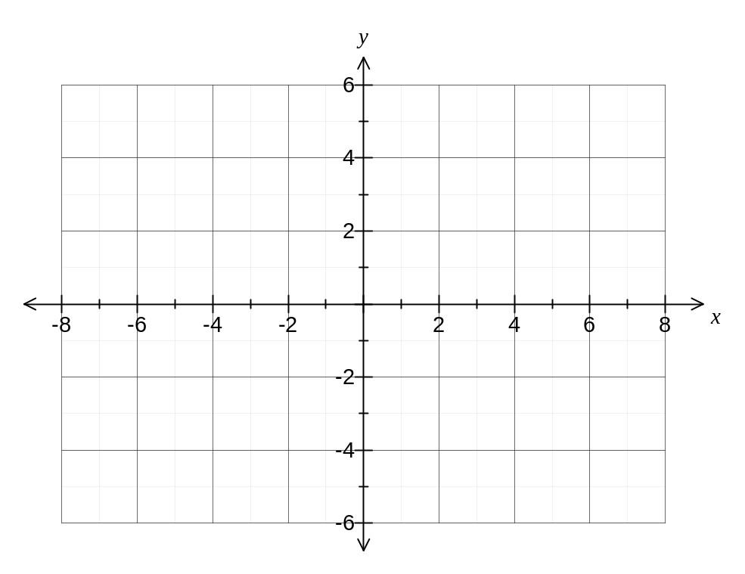

(b) Add the graph of 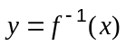, the inverse of , to the axes above. (2 marks)

(c) State

(i) the domain of . (1 mark)

(ii) the range of 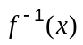. (1 mark)

(d) Describe how to obtain the graph of from the graph of 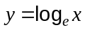. (2 marks)

Question 20 (5 marks)
(a) If 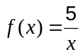, write down an expression for . (1 mark)

(b) Differentiate from first principles, using the formula 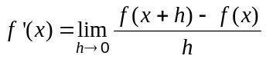.
(4 marks)

Additional working space

Question number: _________

Additional working space

Question number: _________

This examination paper may be freely copied, or communicated on an intranet, for non-commercial purposes within educational institutes that have purchased the paper from WA Examination Papers provided that WA Examination Papers is acknowledged as the copyright owner. Teachers within purchasing schools may change the paper provided that WA Examination Paper's moral rights are not infringed.

Copying or communication for any other purposes can only be done within the terms of the Copyright Act or with prior written permission of WA Examination papers.

Published by WA Examination Papers
PO Box 445 Claremont WA 6910

